**JQuery Basic, Effect and Advanced**

1. **What is jQuery?**

**Ans:** jQuery is a fast, small and feature-rich JavaScript library that simplifies web development by providing easy to use functions for tasks to handling events.

1. **How to apply CSS using jQuery, how to add class and remove class in jQuery, jQuery animation?**

**Ans:** To add the CSS classes to an element we use add class() method, and to remove the CSS class we use remove class() method.

**Syntax:** $(‘selector’).addclass(‘classname’);

$(‘selector’).removeclass(‘classname’);

$(‘selector’).animate({width: ‘200px’},1000);

1. **How to create slider with animation?**

**Ans:** To create a slider with animation using jQuery, you can utilize functions along with HTML and CSS to get desired effect.

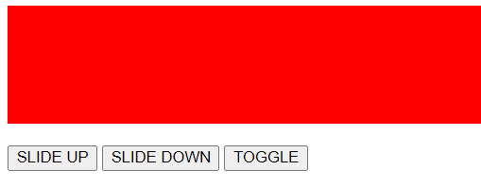

1. **Event bubbling tickling example**

